Westover, J. H. (2026). The Job Characteristics Model in the Age of Large Language Models: A Multi-Architecture Analysis of AI-Augmented Work Design.
RQ1: How does LLM integration affect the five core job characteristics of the JCM, and do these effects vary systematically across different LLM architectures?
RQ2: What role do implementation factors—including override authority, advanced feedback features, customization intensity, and multi-architecture portfolios—play in moderating the relationship between LLM augmentation and job characteristics?
RQ3: How do individual worker characteristics, particularly growth need strength (GNS), interact with LLM architectures and implementation approaches to influence motivating potential and job satisfaction over time?
Olafsen, A. H., Marescaux, B. P., & Kujanpää, M. (2025). Crafting for autonomy, competence, and relatedness: A self‐determination theory model of need crafting at work. Applied Psychology, 74(1), e12570.
job crafting is referred to as proactive behaviors and cognitions that employees engage in with the aim of aligning their jobs with their own preferences, motives, and passions (Wrzesniewski & Dutton, 2001).
**Article offers 7 interesting propositions
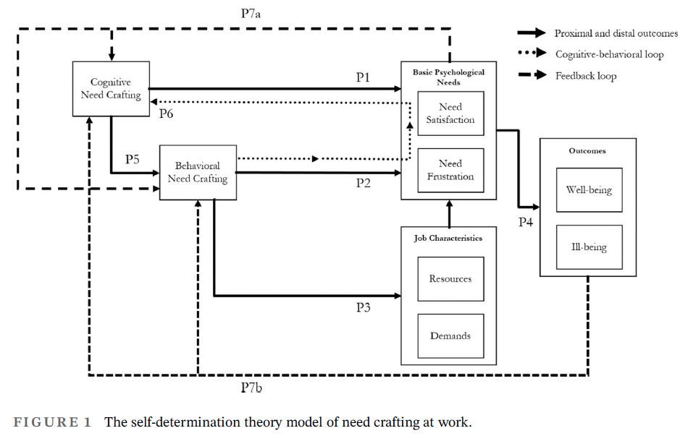
Callari, T. C., & Puppione, L. (2025). Meaningful work as shaped by employee work practices in human-AI collaborative environments: a qualitative exploration through ideal types. European Journal of Innovation Management, 28(10), 5001-5027.
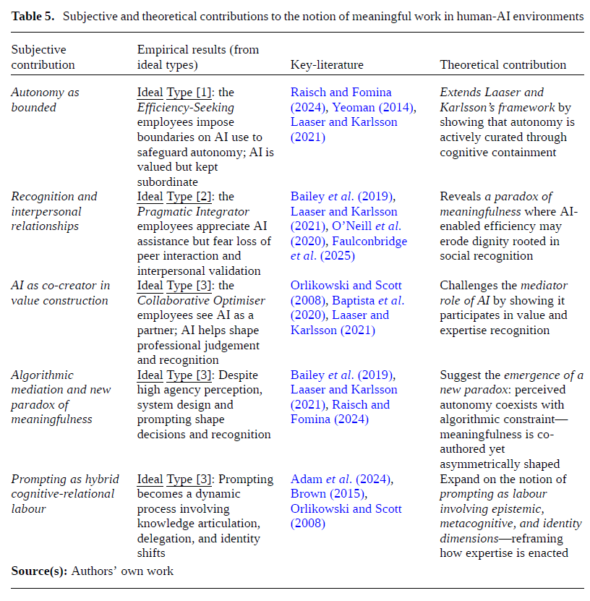
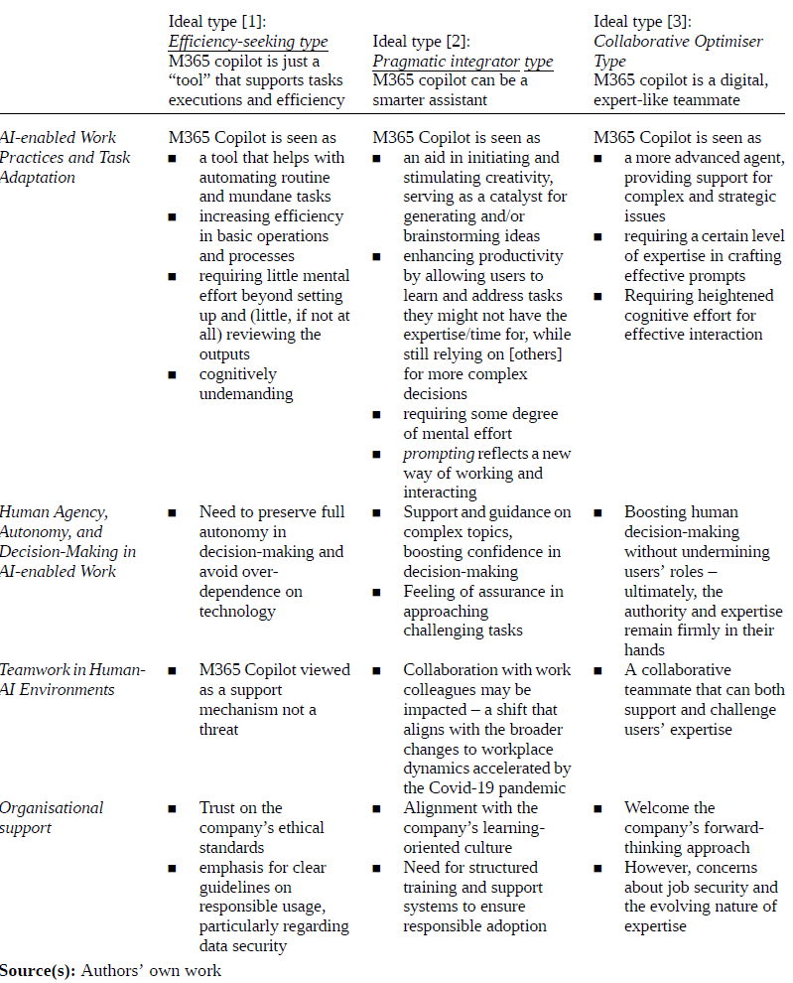
Blustein, D. L., Lysova, E. I., & Duffy, R. D. (2023). Understanding decent work and meaningful work. Annual Review of Organizational Psychology and Organizational Behavior, 10(1), 289-314.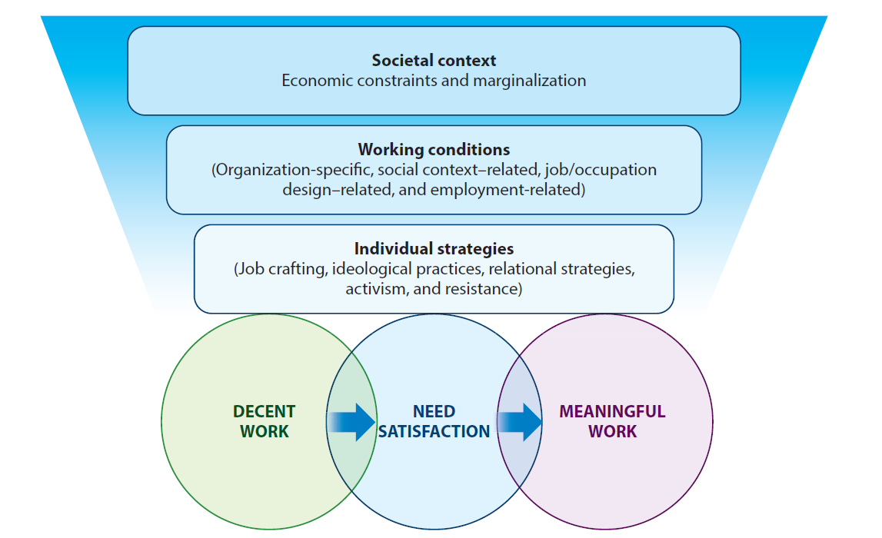
Arora, N., & Garg, N. (2025). Meaningful work in the digital age-A comprehensive review and framework. Human Resource Development International, 28(2), 169-193.
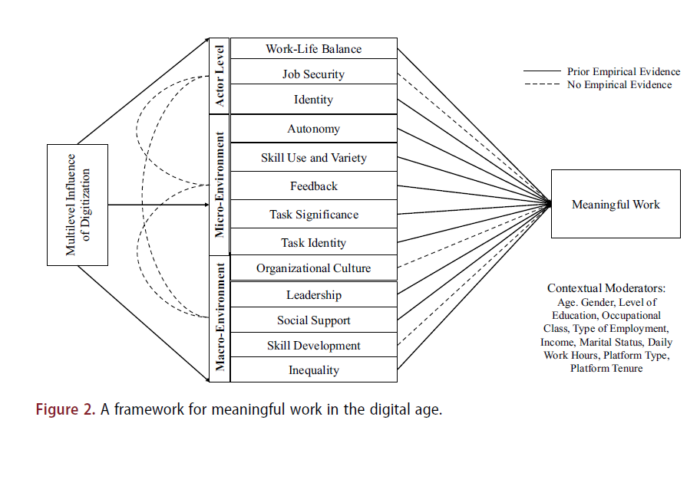
Bankins, S., & Formosa, P. (2023). The ethical implications of artificial intelligence (AI) for meaningful work. Journal of Business Ethics, 185(4), 725-740.
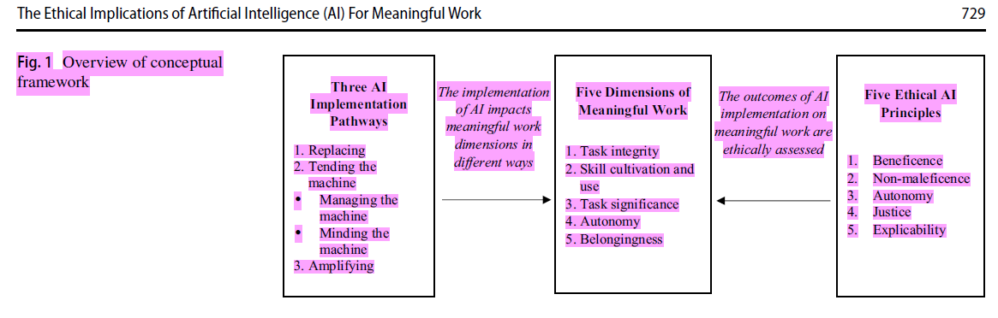

Zhang, L., & Amos, C. (2026). Artificial intelligence and work meaningfulness. Behaviour & Information Technology, 1-15.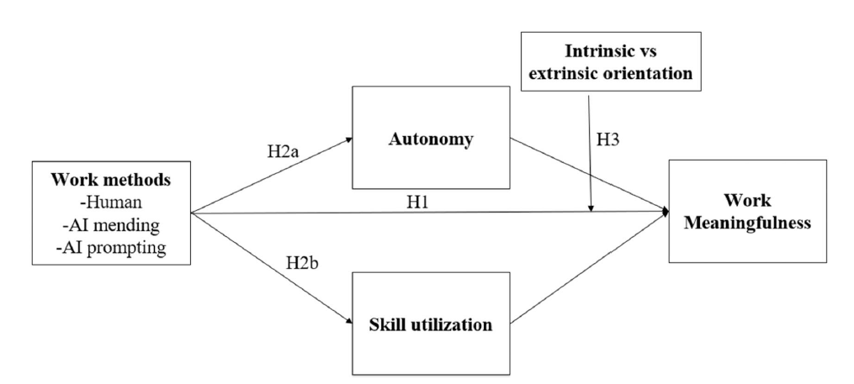
https://arxiv.org/pdf/2607.29380
Test model
JCM
MPS = [(Skill Variety + Task Identity + Task Significance) / 3] × Autonomy × Feedback
But add dvs of wellness and meaningfulness as well
Siop poster:
JDS and job characteristics model –
AI: we believe this will be more important as world of work deals with AI integrating it into roles that would be survey based
Next week: propose a framework of a study
Stress/motivation/wellbeing/satisfaction/meaning
ethics
AI implementation (IV)
Could use JCM 3 predictors
GNS – moderator
Ability to job craft – vertical scaling/autonomy
How are people being asked to use AI – enhance what doing?
Is AI supplementing your work? Or complementary?
JAP: no person is an island: unpacking the work –
Ganti et al paper – for other measures of growth
Knowledge work
7/2/2026
Adobor (2026)
• “solutionism” trap
• premature problem closure (would a developer framework toward management be effective
here [thinking GitHub] instead of the author’s governance–in–use playbook)
– disciplined judgement under uncertainty deemed important, but is this just temporal?
Jonathan H. Westover – “The Job Characteristics Model in the Age of Large Language Models:
A Multi-Architecture Analysis of AI-Augmented Work Design”
GNS maybe non–linear with AI? (HIGH GNS want to be stretched – LOW GNS prefer routine
over challenge) Maybe revisit the construct – redefine and place within nomological network
specifically with the “future of work” in mind (already hate that)
Revisiting JCM in context of AI – changing nature of work.
Survey of what layoffs look like – new jobs vs old jobs
Project idea (generally something AI–ish): 􀀀
DVs: + Stress & Well–being (William) + Motivation (Kulas) + Satisfaction (Alicia)
IVs: + AI implementation (organization–wide) + Ability to Job Craft
Covariates: + Tenure
William: Alicia: GNS Kulas: how AI impacts layoffs (popular media/polling); how ppl are
being asked to use AI? (be more prouctive or AI taking over key aspects of their job)
5/21/2026
Chatting with William
What resources are people losing and what impact does it have?
• Current social aspect of workplace and how work is being done
• Meaningful work (Lips-Wiersma, 2012)
• Proactive personality or Openness to Experience (Kulas build concept of individual
difference predictors)
• Are devs now job analysts? (also fully executing the agent after specifying work activities)
Are you willing to try it?
1
7/23/2026
Notes from Alicia:
Growth Need Strength (GNS)
“As noted earlier, there is now substantial evidence that differences among people moderate
how they react to their work, and individual need strength appears to be a useful way to
conceptualize and measure such differences. The basic prediction is that people who have
high need for personal growth and development will respond more positively to
a job high in motivating potential than people with low growth need strength.”
(Hackman & Oldham, 1976, p. 258).
Options for measurement:
Job Diagnostic Survey (JDS) Growth Need Strength Scales, Hackman & Oldham (1975, 1980)
1. “Job Choice” GNS Scale
• Respondents choose between pairs of hypothetical jobs.
• Measures preference for challenging, growth-oriented work versus comfort, security, or
other job features.
• I have the original article, but not the items themselves for the job choice measure – these
two scales seem to first be described here: https://werkwelzijnenmotivatie.wordpress.
com/wp-content/uploads/2020/05/hackman-oldham-1975.pdf
2. “Would-Like” GNS Scale
• Respondents indicate how much challenge, responsibility, learning, autonomy, and growth
they would like in a job, rated from 1 (not at all) to 5 (very much). I think these are the
items themselves, although these (1975?) differ from the original in the 1974 tech report.
I will attach the tech report – see the scoring key for which items in the appendix are to
be summed for the GNS measure there.
“Considering all the things that are personally important to you in your work, how important
is it to you to have…”
1. ‘stimulating and challenging work’,
2. ‘creative and imaginative work’,
3. ‘a chance to exercise independent thought and action’,
4. ‘opportunities to learn new things’,
5. ‘opportunities for achievement’, and
6. ‘opportunities for personal growth and development’.
Higher-Order Need Strength (HONS) Measures, Hackman & Lawler (1971)
This appears to be prior to GNS: higher-order need strength, reflecting desires for:
2
• Achievement
• Challenge
• Responsibility
• Personal accomplishment
8/6/2026
Note – some previous notes seem to have been misplaced
SIOP 2027 submission deadline is October 7
Each of us propose the framework of a “study” to bring to the larger group on 8/13
References
Blustein, D. L., Lysova, E. I., & Duffy, R. D. (2023). Understanding decent work and
meaningful work. Annual Review of Organizational Psychology and Organizational Behavior,
10(1), 289-314.
Lips-Wiersma M, Wright S (2012) Measuring the meaning of meaningful work: development
and validation of the comprehensive meaningful work scale (CMWS). Group Org Manag
37(5):655–685
@article{lysova2019fostering, title={Fostering meaningful work in organizations: A multi-level
review and integration}, author={Lysova, Evgenia I and Allan, Blake A and Dik, Bryan
J and Duffy, Ryan D and Steger, Michael F}, journal={Journal of vocational behavior},
volume={110}, pages={374–389}, year={2019}, publisher={Elsevier} }
3

